**SAR ADC PROJECT**

**Introduction (Behavioral Models)**

1. **Inverter**

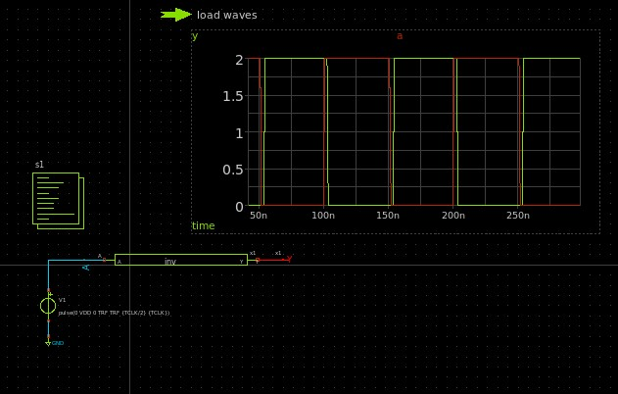

**2-nand gate**

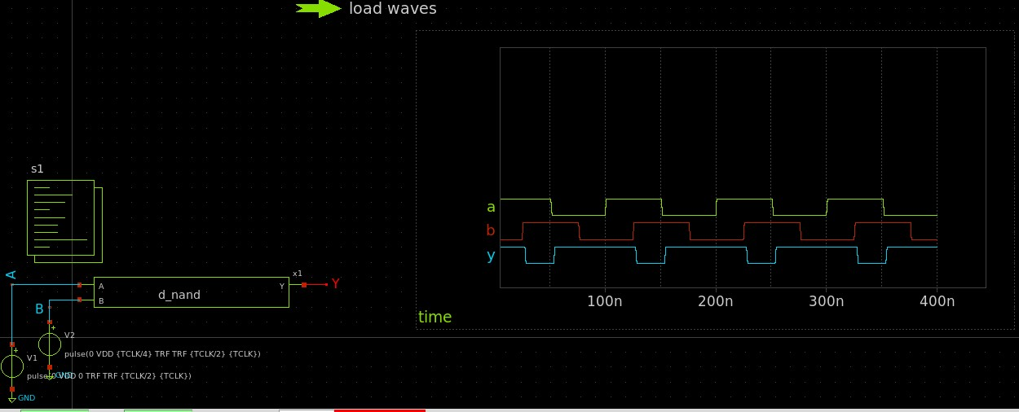

**3-Nor gate**

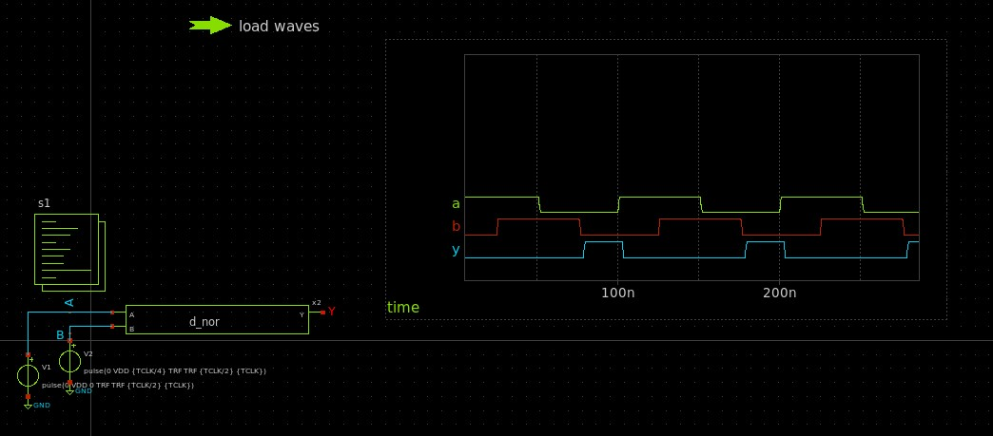

**4- d-flipflop**

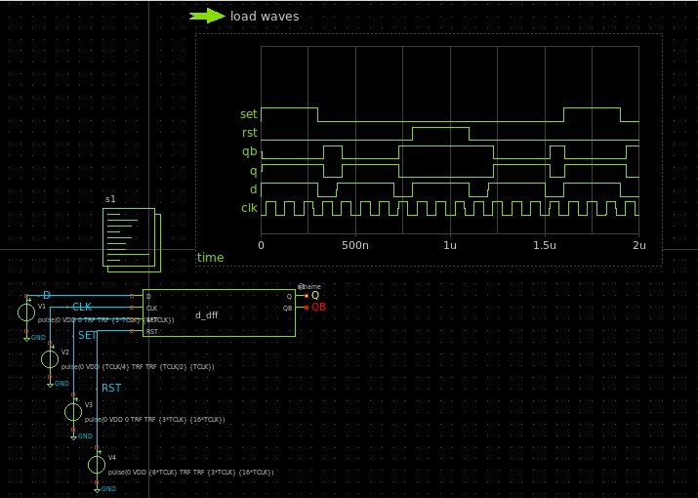

**5- comparator**

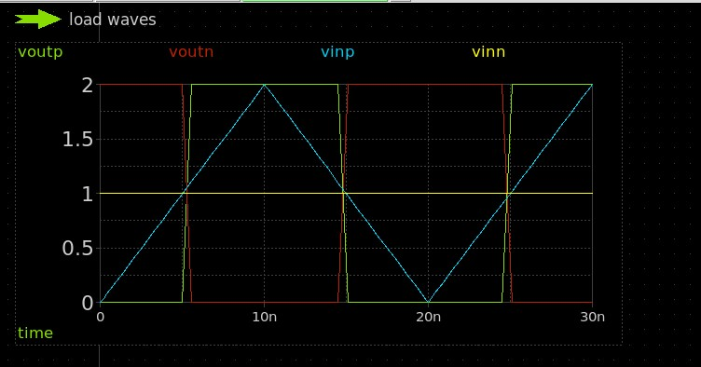

**Part 1**

**Sar logic schematic**

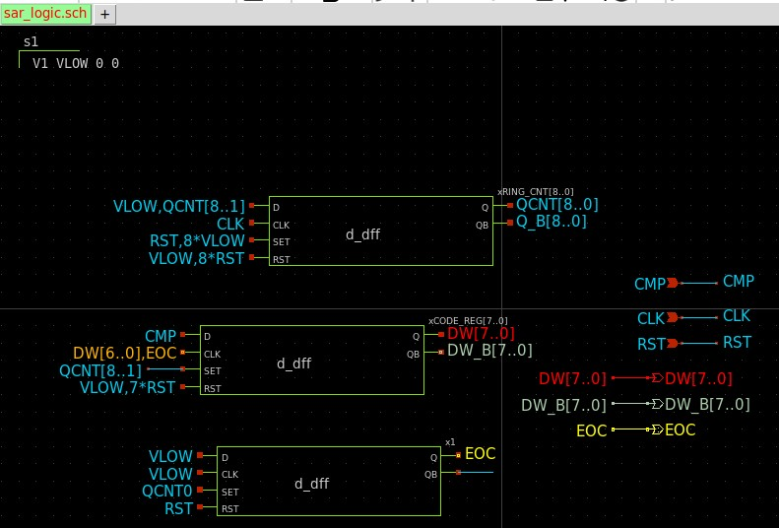

**Sar logic tb**

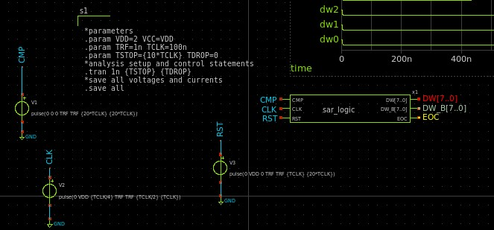

**Simulation results when:**

a-CMP is all zeros

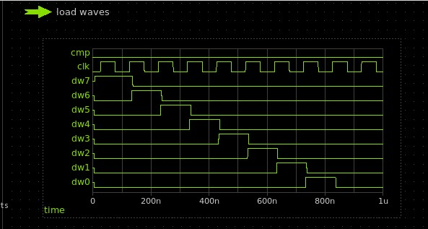

b-CMP is all ones

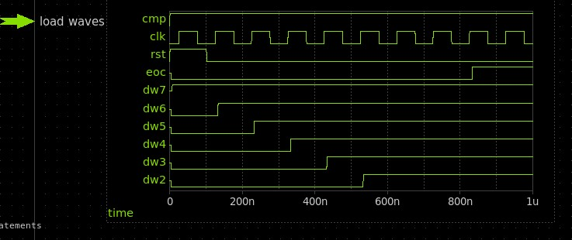

c-CMP is alternating

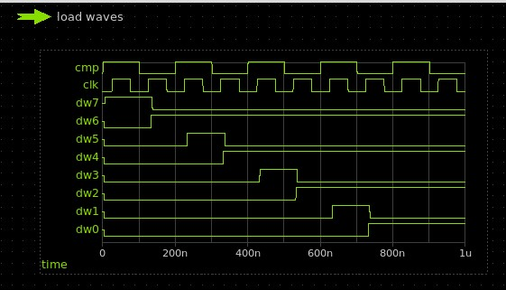

|  |  |  |  |  |  |  |  |  |  |  |  |
| --- | --- | --- | --- | --- | --- | --- | --- | --- | --- | --- | --- |
| Clock cycle | DW 7 | DW6 | DW5 |  | DW4 | DW3 |  | DW2 DW1 DW0 CMP |  |  |  |
| 1 (RESET) | 0 | 0 | 0 |  | 0 | 0 |  | 0 0 0 |  |  |  |
| 2 | 1 | 0 | 0 |  | 0 | 0 |  | 0 0 0 B7 |  |  |  |
| 3 | 1 | 1 | 0 |  | 0 | 0 |  | 0 0 0 B6 |  |  |  |
| 4 | 1 | 1 | 1 |  | 0 | 0 |  | 0 0 0 B5 |  |  |  |
| 5 | 1 | 1 | 1 |  | 1 | 0 |  | 0 0 0 B4 |  |  |  |
| 6 | 1 | 1 | 1 |  | 1 | 1 |  | 0 0 0 B3 |  |  |  |
| 7 | 1 | 1 | 1 |  | 1 | 1 |  | 1 0 0 B2 |  |  |  |
| 8 | 1 | 1 | 1 |  | 1 | 1 |  | 1 1 0 B1 |  |  |  |
| 9 | 1 | 1 | 1 |  | 1 | 1 |  | 1 1 1 B0 |  |  |  |
|  |  |  |  |  |  |  |  |  |  |  |  |

This table states how the SAR logic works in case CMP = all ones .

**Comment :**

The SAR ADC operates by using a binary search method to approximate the input signal. It starts by setting the most significant bit (MSB) to 1 while keeping the rest as 0. This digital value is converted to an analog voltage using a DAC, which is then compared to the input signal. If the DAC output is higher than the input, the bit is cleared back to 0. otherwise, it remains 1. The process then moves to the next bit, setting it to 1 and repeating the comparison. This iterative approach continues from MSB down to the least significant bit (LSB), progressively doing the digital approximation of the input signal. Once all bits are determined, the EOC signal is asserted, indicating that the final digital output is ready.

**Part 2**

**Transmition gate schematic**

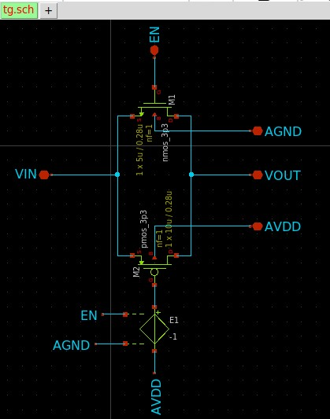

**Symbol:**

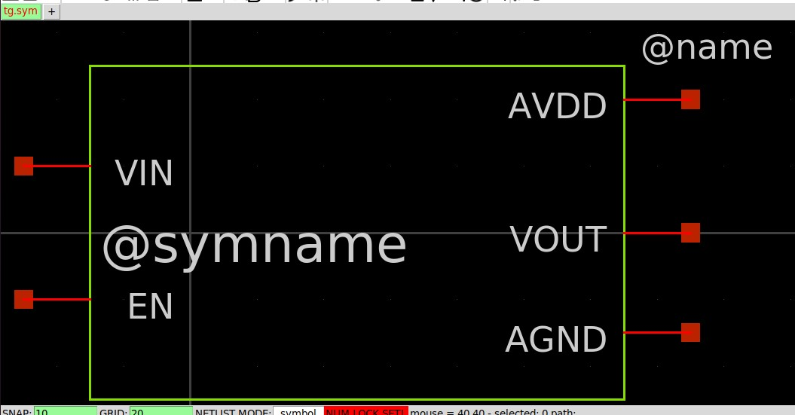

**Part 3**

**Bottom-Plate Switch**

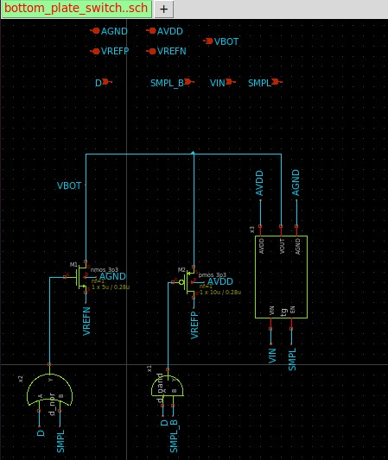

**Symbol:**

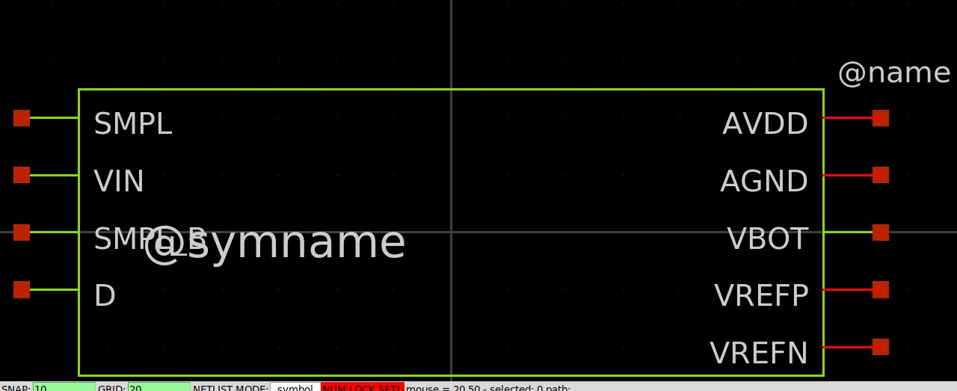

**Part4**

**Capacitave DAC schematic :**

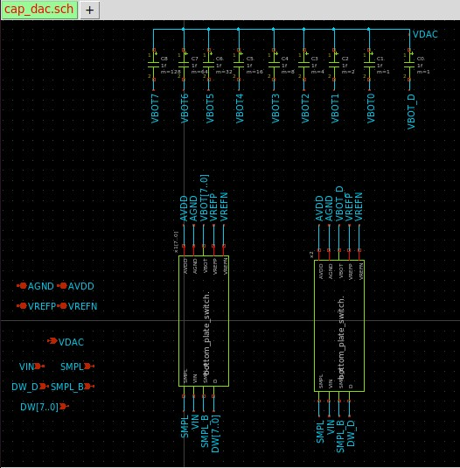

**Symbol:**

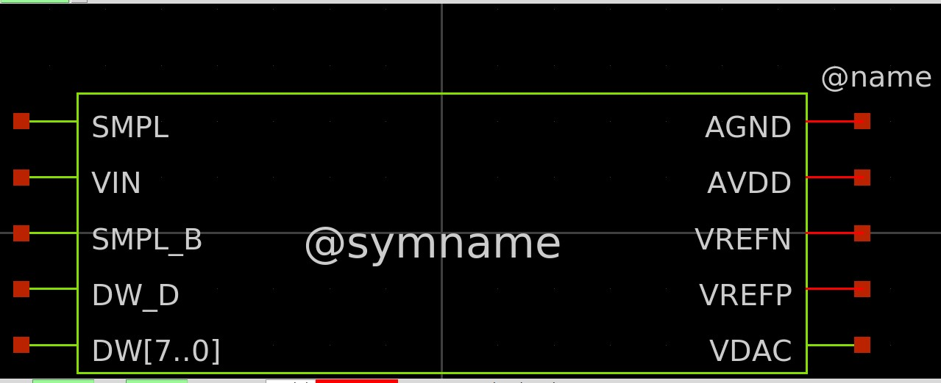

**SAR ADC DESIGN**

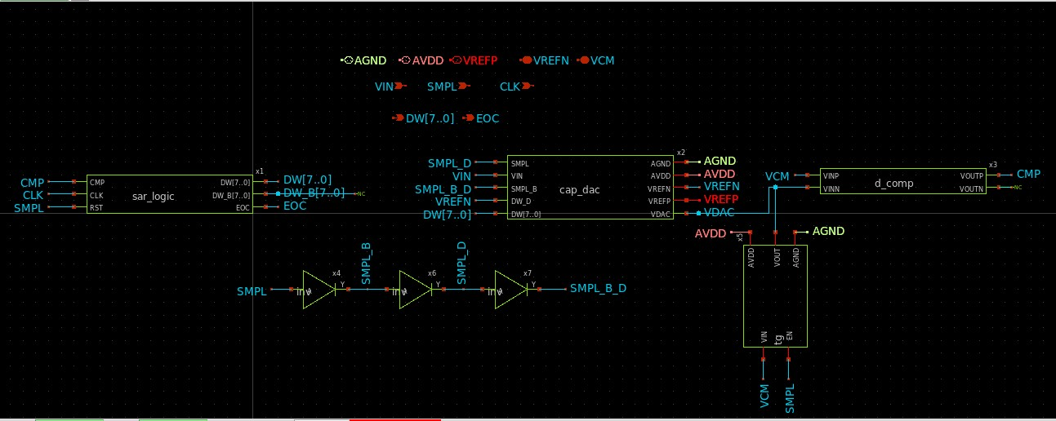

**Symbol :**

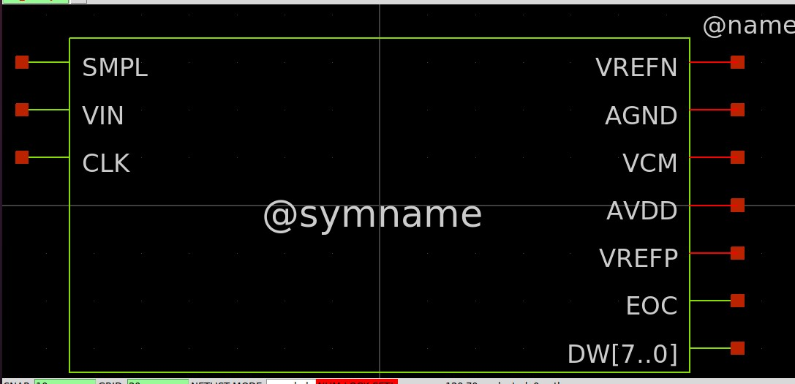

**SAR ADC TestBench:**

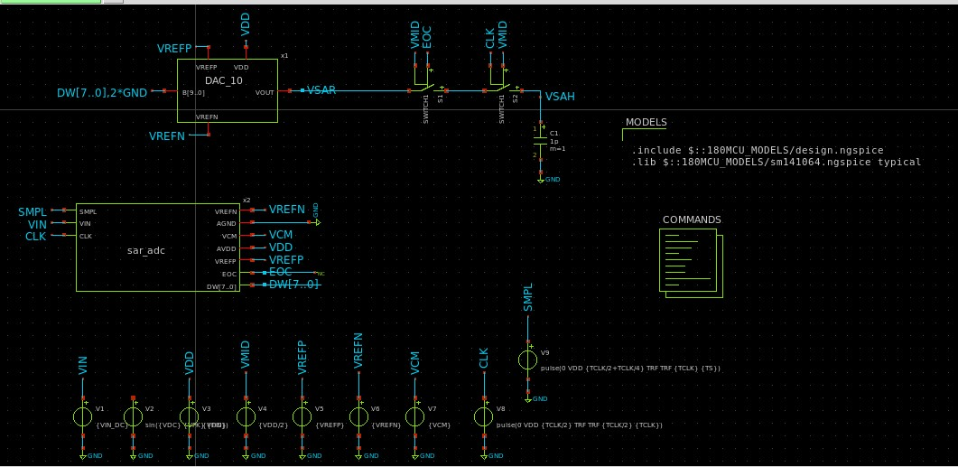

**Part5(DC TEST)**

**Case (1) VIN = VREFN :**

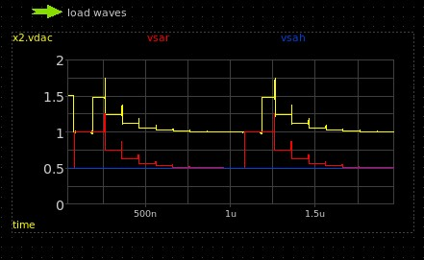

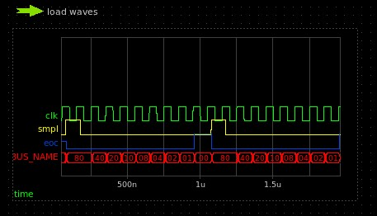

**Case (2) VIN = VREFP :**

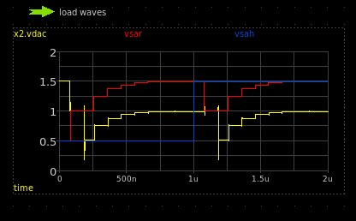

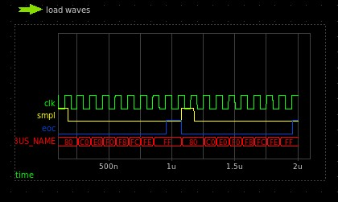

**Case (3) VIN = VREFN + (128+32+8+2+0.5)*VLSB:**

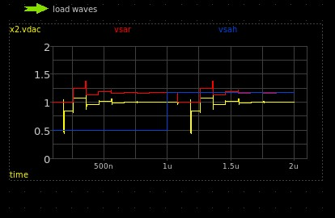

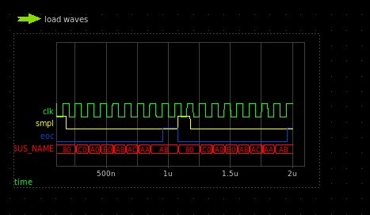

**Part 6 (Sine Wave Test)**

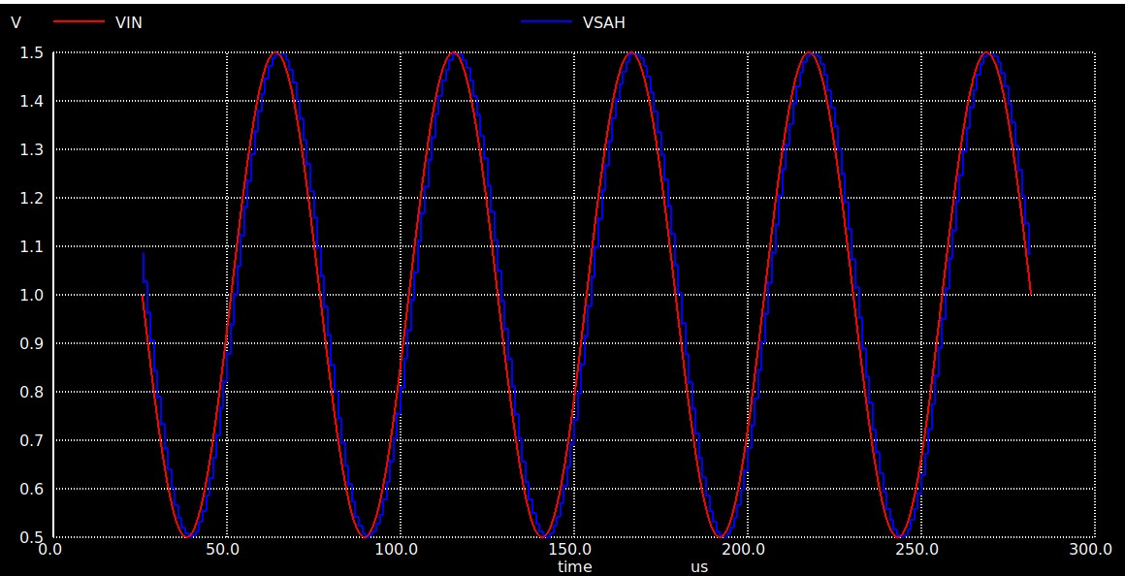

**FFT:**

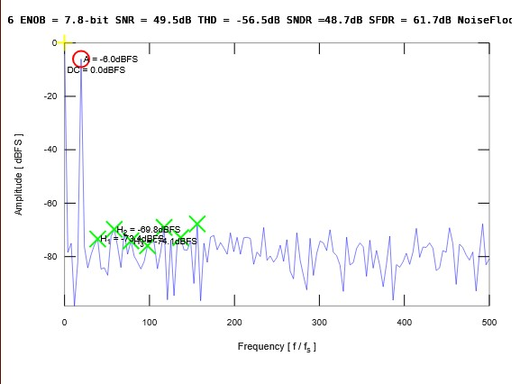

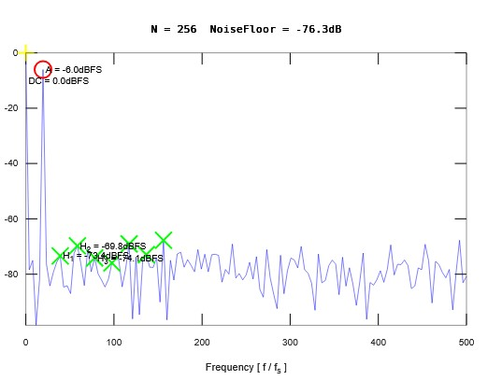

|  |  |
| --- | --- |
| Spec | Reported value |
| ENOB | 7.8 bit |
| SINAD | 48.7 dB |
| SNR | 49.5 dB |
| SFDR | 61.7 dB |
| THD | -56.5 dB |
| SIGNAL POWER | -9 dB (-6 dB rms) |
| DC POWER | 0 dB |

**COMMENT :**

SNR – SNDR = 0.9 dB (a reasonable value that state that the distortion effect on SNR is very weak here).

Effective number of bits is 7. 8 Which is nearly 8 bits and this is what we aim to design (8-bit SAR ADC ).

SFDR is large due to the weakness of distortions components (low level of harmonics) and power efficiency .

Noise floor is -76.3 dB indicates a good design .